Sshhh… curtains

Curtains help to make a room quieter by absorbing sound.

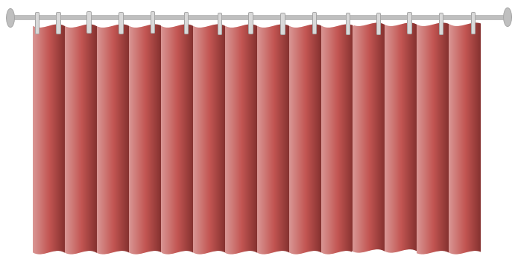

Which statements about curtains absorbing sound do you think are right?
For each statement, tick (✓) one column to show what you think.
Places |  | I am sure this is right | I think this is right | I think this is wrong | I am sure this is wrong
A | Curtains absorb all sound that reaches them
B | Sound makes particles in curtains vibrate more quickly
C | Particles in curtains trap sound
D | The folds in curtains help them absorb sound

Physics > Big idea PSL: Sound, light and waves > Topic PSL1: Sound and light > Key concept PSL1.1: Production and transmission of sound
Diagnostic question
Sshhh… curtains

Overview
Learning focus: | Sound needs a medium to travel through. It radiates out from a source in straight lines in all directions and when it strikes an object or new material it is transmitted, reflected, scattered or absorbed – or a combination of these.
Observable learning outcome: | Explain why sound is absorbed by soft surfaces and reflected or scattered by hard ones.
Question type: | Confidence grid
Key words: | Absorb, reflect, scatter, particles, vibrations

What does the research say?
When sound is absorbed Asoko et al (1991) found that students often described the absorbing surface as ‘trapping’ the sound and very few referred to vibrations in the absorbing material.
This question explores students’ understanding about how sound is absorbed.
Ways to use this question
Students should complete the confidence grid individually. This could be a pencil and paper exercise, or you could use an electronic ‘voting system’ or mini white boards and the PowerPoint presentation.
If there is a range of answers, you may choose to respond through structured class discussion. Ask one student to explain why they gave the answer they did; ask another student to explain why they agree with them; ask another to explain why they disagree, and so on. This sort of discussion gives students the opportunity to explore their thinking and for you to really understand their learning needs.
Differentiation
You may choose to read the questions to the class, so that everyone can focus on the science. In some situations it may be more appropriate for a teaching assistant to read for one or two students.
Expected answers
B and D are correct.
For answer D, the folds in the curtain mean that some of the sound that is not absorbed by the curtains is reflected (and scattered) onto other parts of the curtain where part of it is then absorbed.

How to respond - what next?
For answer A, only some of the sound is absorbed, the rest is reflected and because the curtain is not smooth it is also scattered.
Answer C suggests sound is a material substance that can be stored.
If students have misunderstandings about how soft surfaces absorb sound, it can help to model the particles in the air hitting an absorbing surface. Students spaced across a room can represent air particles, and a group of students with their arms linked at one end of the line a solid surface.
When a vibration (sound) passing through the air hits the solid, the solid particles vibrate. In a softer surface the links between the solid particles are looser and the particles of the solid vibrate with a greater amplitude and the air particles hitting the surface are pushed back with less force.
The following BEST ‘response activitiy’ could be used in follow-up to this diagnostic question by giving students the opportunity to apply their thinking to a new situation:
- Response activity: Noisy road
Acknowledgments
Developed by Peter Fairhurst (UYSEG).
Images: UYSEG
Reference
Asoko, H. M., Leach, J. and Scott, P. H. (1991). A study of students' understanding of sound 5-16 as an example of action research. Annual Conference of the British Educational Research Association. Roehampton Institute, London.

